# New Hire

# Government Employee Management System (GEMS)

# Quick Guide

# Logging in

Enter the following link in your NMCI computer: <https://aps.navwar.navy.mil>

Verify GEMS system access by clicking on **Employee.**

Plan to meet with your supervisor within 30 days to establish your performance goals and objectives.

# Main_add plan.jpgCreate a New Plan

As a new employee to GEMS, you will see the “Employee Main” screen that shows the current appraisal cycle. Click **Add New Plan** to set up your performance plan.

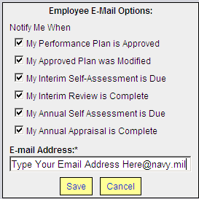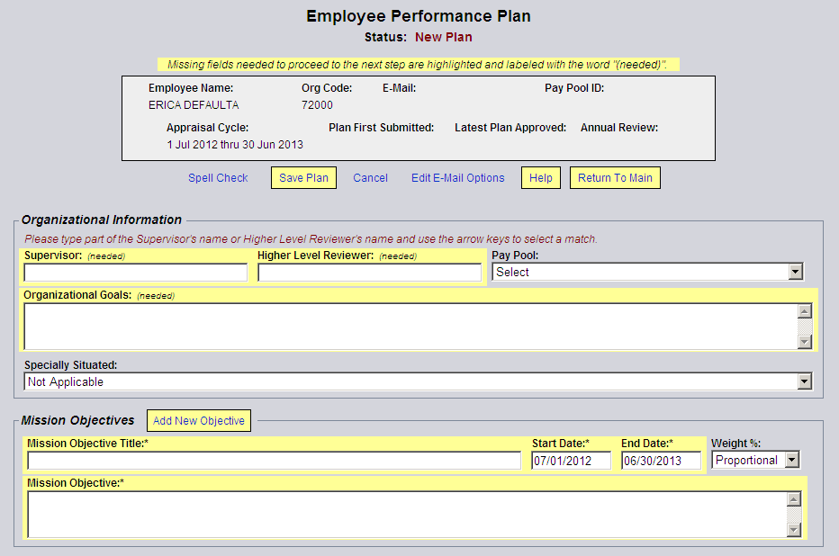Be sure to select Edit E-mail Options link and type your email address in the textbox provided to receive automated notifications.

# Select Supervisor & Higher-Level Reviewer

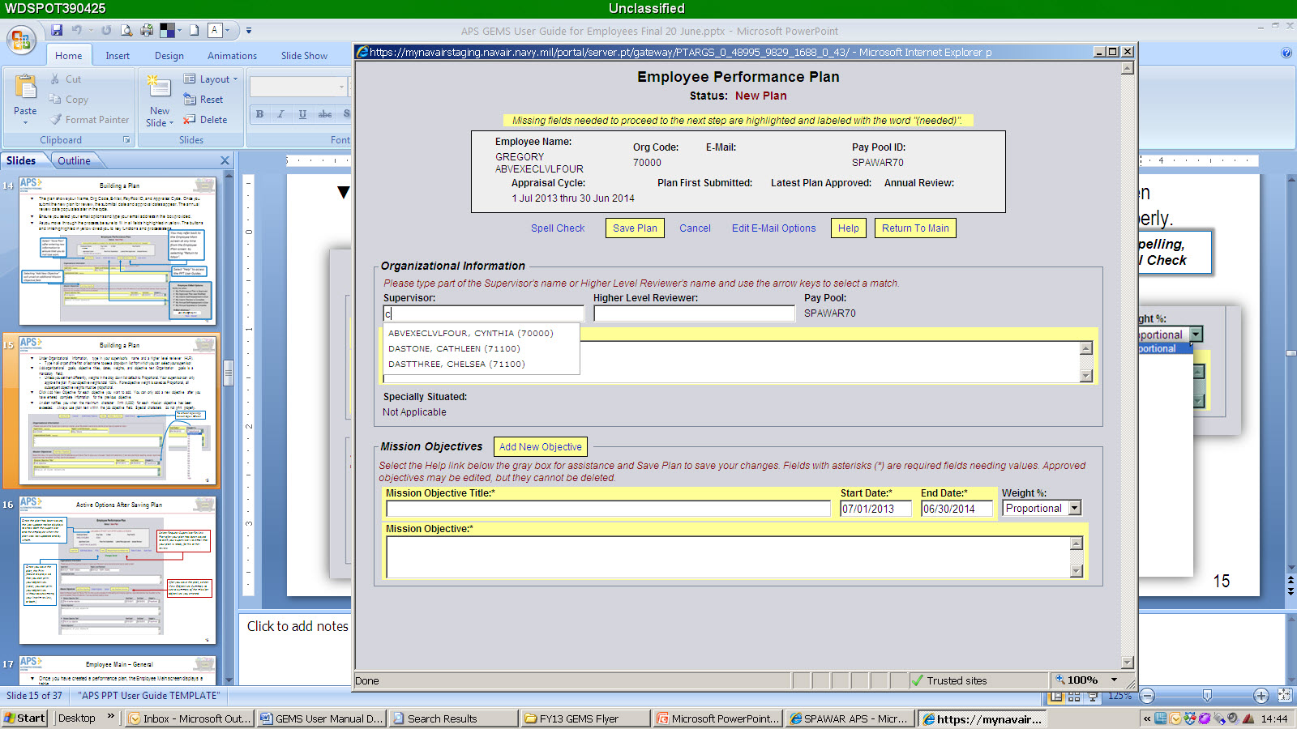You are responsiblie for selecting your supervisor and higher-level reviewer names within your performance plan from the drop-down list.

# Organizational Goal

Enter the organizational goal in the textbox directly beneath the “Supervisor” and “Higher Level Reviewer” textboxes, this will can be provided by your supervisor or administrative officer.

# How to Set Objectives

In the “Mission Objectives” section, click **Add New Objective** each time you wish to add an objective. You cannot add another objective until all required (highlighted) fields of the current objective contain information.

* Enter the “Mission Objective Title” and write the description in the box below it using the SMART methodology.
* Do not use special characters (such as bullets) in textboxes; they do not print properly.
* Change the start and end dates if an objective is to have a specific timeline (shorter than the full performance year). Default dates will always be the current appraisal cycle or your start date.
* Apply a value of importance to objectives, defining a greater significance of one objective over another and setting a percentage of the total performance evaluated. Unless you specify a weight percentage from the drop-down list, all weights are distributed as proportional.
* GEMS will not allow a plan to be approved by the supervisor if the percentage weights do not equal 100%.

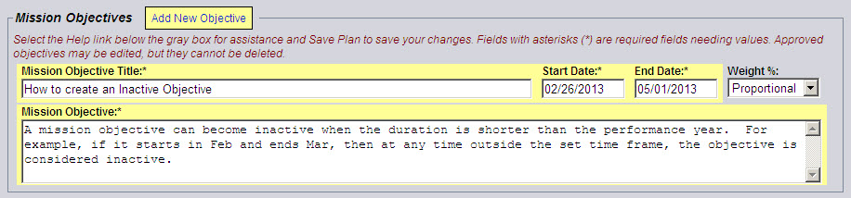

[Grab your reader’s attention with a great quote from the document or use this space to emphasize a key point. To place this text box anywhere on the page, just drag it.]

# Request Supervisor Approval

After completing your three to five performance objectives, click **Request Supervisor Review Plan**. A confirmation message appears (shown below). Click **Proceed** to send an email to your supervisor that your plan is ready for review

For information on how to write objectives or about APS please go to the following website: *https://flankspeed.sharepoint-mil.us/sites/NAVWAR/80CorpOps/SitePages/8.0.3\_Alternative\_Personnel\_System.aspx*

If you have any issues, please contact the APS Help Desk as soon as possible. The Help Desk can be reached at: 619-524-7743 or [Aps.customer.support@navy.mil](mailto:Aps.customer.support@navy.mil).

